# **Dividend Premium Alpha Strategy**

# Background:

The dividend month premium strategy is based on the observation that stocks tend to outperform in the month before they pay dividends. This anomaly was first documented by Hartzmark and Solomon (2013) in their paper “[The Dividend Month Premium](https://papers.ssrn.com/sol3/papers.cfm?abstract_id=1930620)” published in the Journal of Financial Economics.

# Underlying Logic:

1. Investor Attention: Dividend announcements draw attention to stocks, potentially increasing demand.

2. Tax-Motivated Trading: Investors may buy before the ex-dividend date to capture the dividend and qualify for preferential tax treatment.

3. Liquidity Provision: Some investors may provide liquidity to those seeking to capture dividends, earning a premium for their services.

4. Behavioral Biases: Investors may overvalue the perceived benefit of receiving dividends, leading to irrational buying pressure.

# Research Algo:

1. Data Loading and Preparation:

- Loads dividend data from a CSV file and stock return data from a Parquet file.

- Creates a date range for each dividend event, from announcement date to 30 days after the ex-dividend date.

2. Data Merging:

- Merges the dividend event data with stock return data using date overlaps.

- Calculates the number of days until the ex-dividend date for each stock-date pair.

3. Exploratory Data Analysis:

- Plots average returns relative to market returns against days until ex-dividend date.

- Includes error bars to show statistical significance.

- Plots the number of observations for each day relative to the ex-dividend date.

4. Strategy Implementation:

- Filters data to focus on the period 14 to 3 days before the ex-dividend date.

- Calculates portfolio returns by averaging stock returns minus market returns for each date.

- Aggregates returns to a monthly level.

5. Performance Analysis:

- Runs regressions to analyze the strategy's performance:

a. Simple average return (alpha)

b. Market-adjusted return (alpha with market beta)

- Examines performance under different minimum portfolio size constraints (N > 5, 10, 20)

# Findings:

Testing Market: India

Testing Period: 2000-2024

* For all dividend types: (vertical lines are -14 calendar days, 0 calendar days, and +7 calendar days around ex-date)

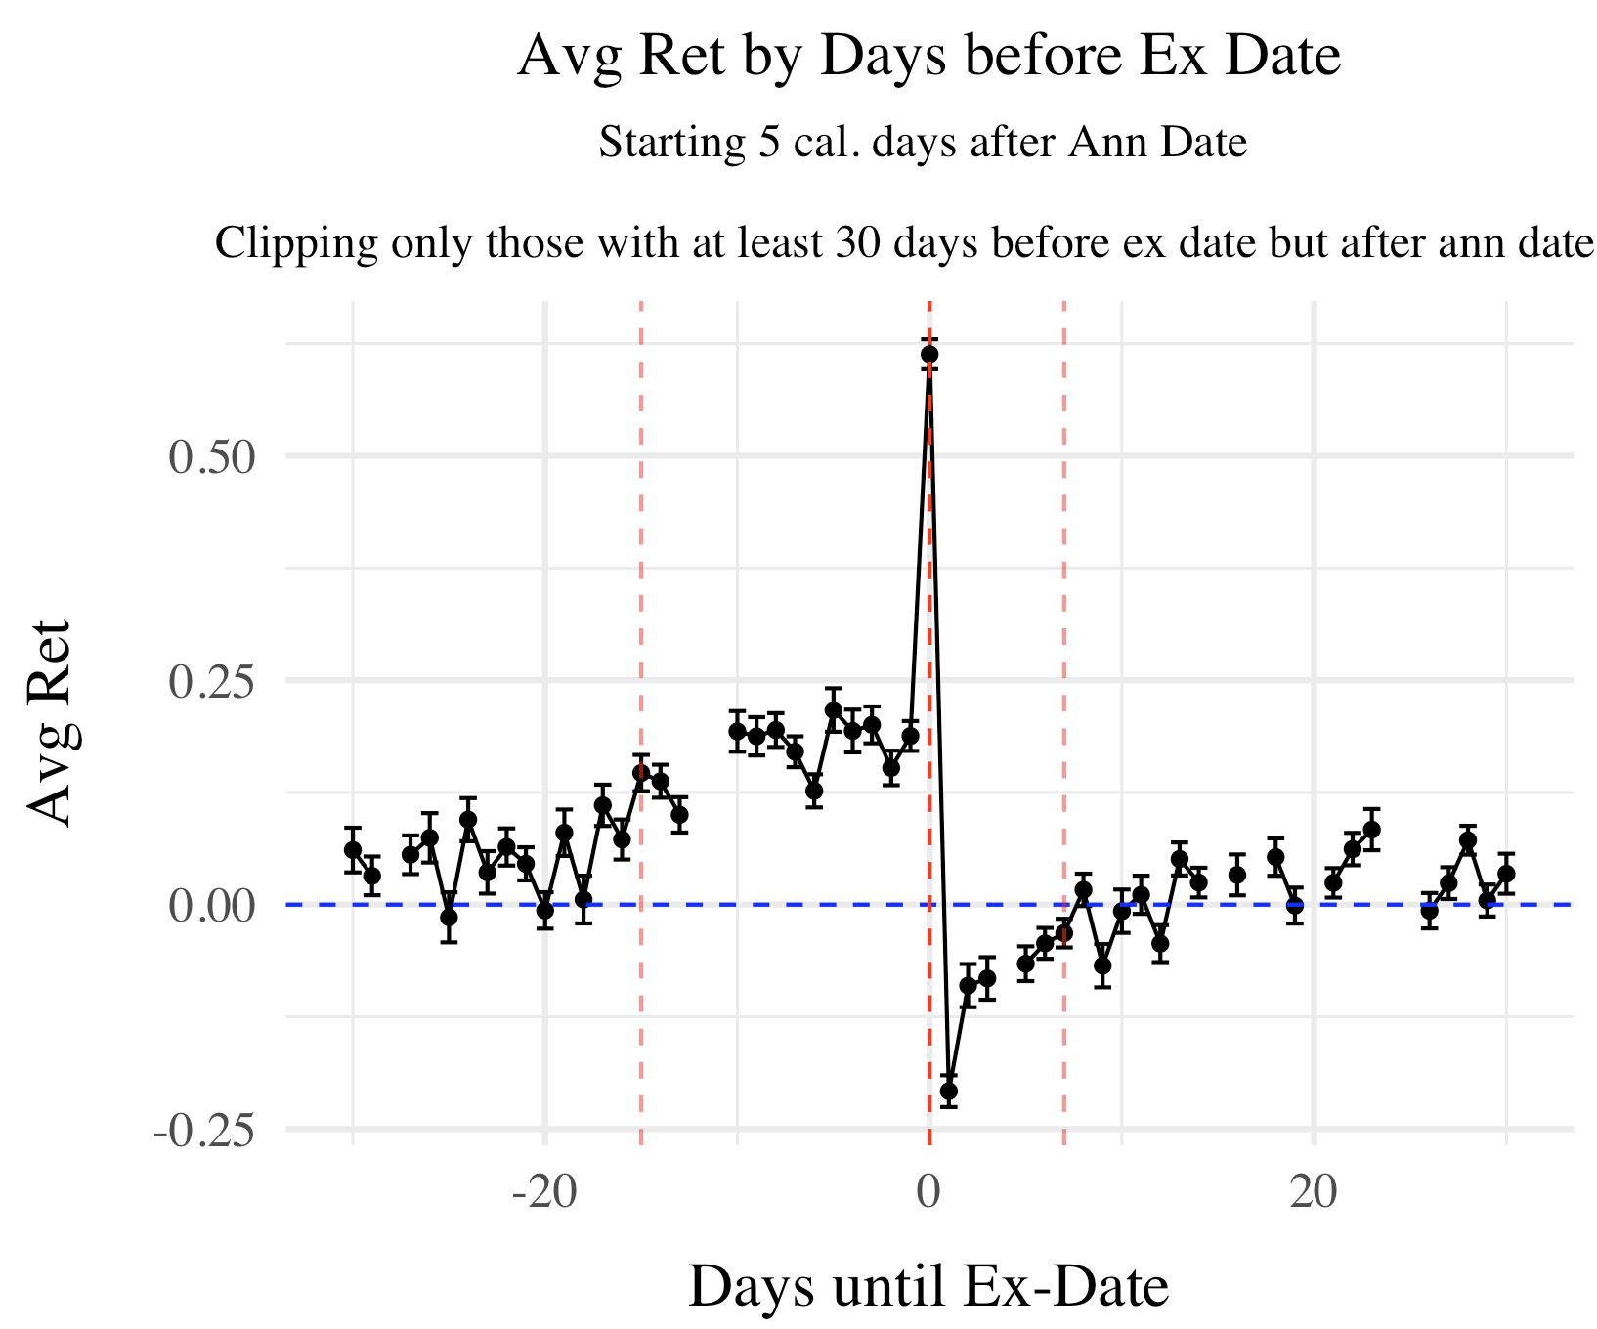

When testing alpha, we rely on monthly data, which is derived from aggregating trading days and assuming that non-trading days have a 0% yield. It's important to note that when going long on a stock, you are effectively shorting the market (assuming a beta of -1 although estimated betas average around 0.6 at the stock level and individual beta estimates are not very accurate).

Our aim is to analyze monthly alphas rather than alphas at the event level. Therefore, we convert the daily trading strategy into monthly returns before running regressions to obtain more stable results.

* For strat (after 2010): go long 14 calendar days before ex-date (and this must be at least 5 calendar days after announcement date), and exit the stock 3 calendar days before:

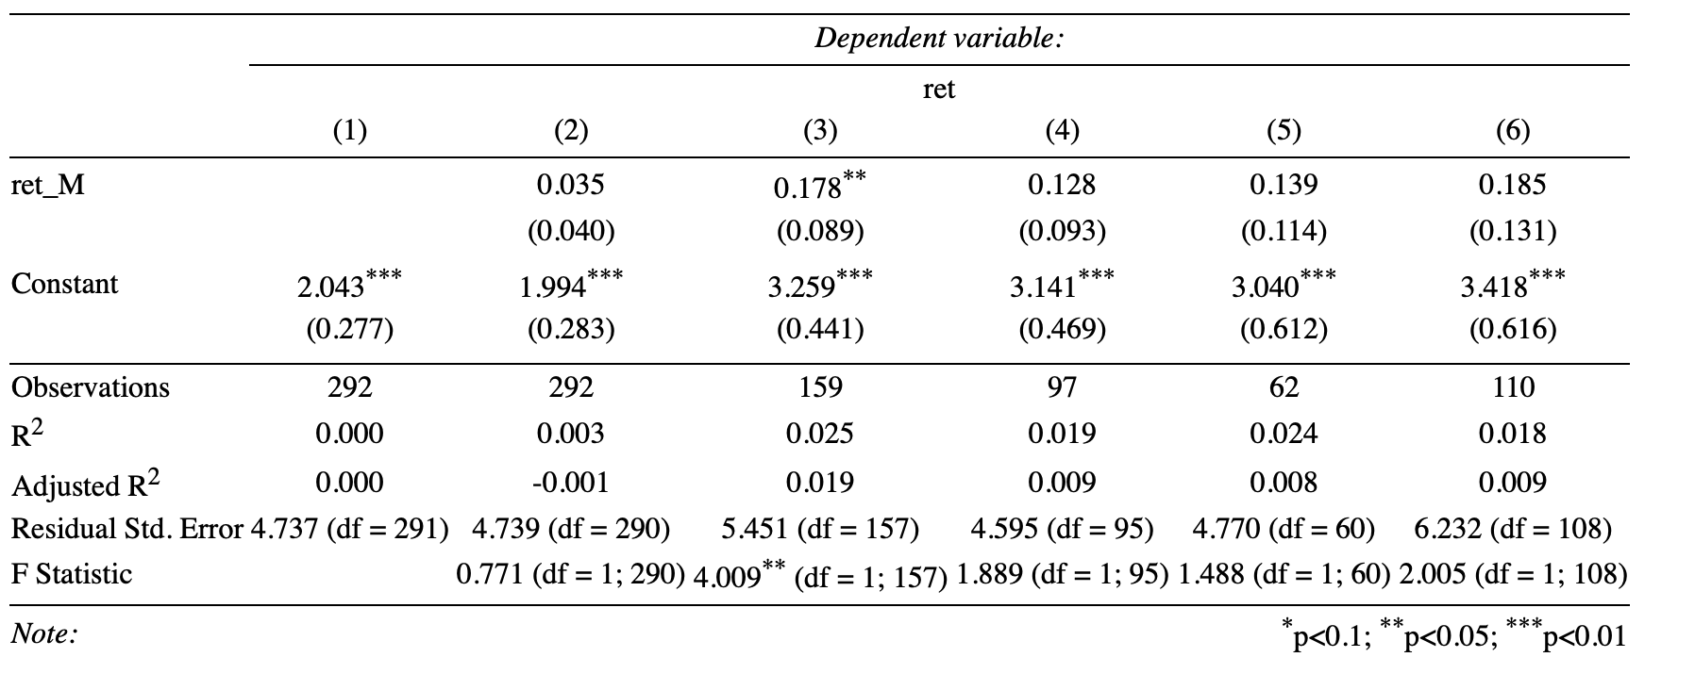

* Column 3 subsets N > 5 avg num stock in that month based on daily avg, col 4 N>10, col 5 N>20, col 6 N < 20
* Seems to make sense. When things are more crowded with more stocks paying dividends in that month on avg, the strategy does worse.
* Overall from Col 1: Avg ret = 24%, SD = 16.5%, SR = 1.49 (all numbers are annualized)
* Before 2010 it tends to do better. Did as robustness - but I’m a bit concerned about data quality before that.
* For strat (after 2010): go short 2 calendar days after ex-date and exit after 7 calendar days:
* 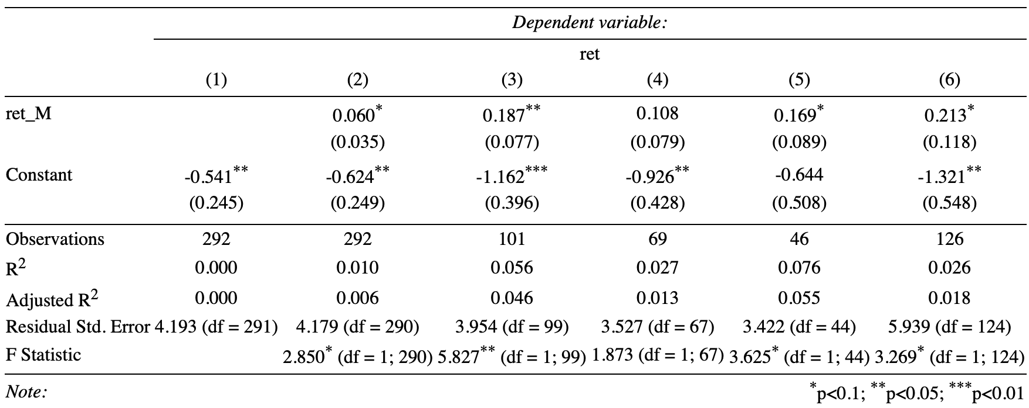
* Overall, from Col 1: Avg ret = -6.492%, SD = 14.5%, SR = 0.45 (all numbers are annualized)

## Proposed Implementation Based on Backtesting

1. **Long Position**: Enter a long position 11 days before the ex-date and exit 3 days before the ex-date, applying a weight of 5 to this position.
2. **Short Position**: Enter a short position 2 days after the ex-date and hold it for a week, using a weight of -2 to control risk and balance the overall Sharpe ratio of the long-short strategy.

Note that this doesn’t even use any predicted dividends yet. And suggests maybe we don’t really need to since we can go daily level incorporating new announcements rather than monthly into the future.